GTB  
  
**QA**

[DEV 20.26] OT-905 | AB | CH-DE | BP | OT-791 Fix  
[DEV 20.26] OT-905 | AB | CH-FR | BP | OT-791 Fix  
[DEV 20.26] OT-905 | AB | CH-IT | BP | OT-791 Fix

**Jira ticket**

<https://jira.uhub.biz/browse/GTBEMEAOPT-905>

**Site**  
[https://www.it.ford.ch/consulenza-agli-acquisti/comprare/prenotazione/configura#](https://www.it.ford.ch/consulenza-agli-acquisti/comprare/prenotazione/configura)

[https://www.de.ford.ch/kaufberatung/kaufen/reservierung/konfigurieren#](https://www.de.ford.ch/kaufberatung/kaufen/reservierung/konfigurieren)

[https://www.fr.ford.ch/conseils-d-achat/acheter/reservation/configurez#](https://www.fr.ford.ch/conseils-d-achat/acheter/reservation/configurez)

**Tags**  
Control  
tt:nwp:opt-791:ab:vhp:floaty-ebp-cta:controL  
  
Challenger  
tt:nwp:opt-791:ab:vhp:floaty-ebp-cta:challenger

**Test location**  
eBP

**Hypothesis**  
Previous AB tests show there can be an uplift of up to 13% in completion rates by making a "Next" CTA more visible in the journey. By making sure that through configuration and pre-order the "Next" CTA is always visible, we can significantly impact final conversion rates.

**Metrics**  
Primary Metric: BP-C

**Test Description**

This is a fix for ticket 897 - After the changes went live on the Summary page of the Mach-E BP journey the pre-order button on this page would appear at the bottom left of the screen, somewhat stickied. This test should not have affected that page. You can compare it with the Control to ensure it’s working. Below is an image of the Summary page on the Deutsch variant with the fix applied. The “Reser-vieren” button was the one that was affected.

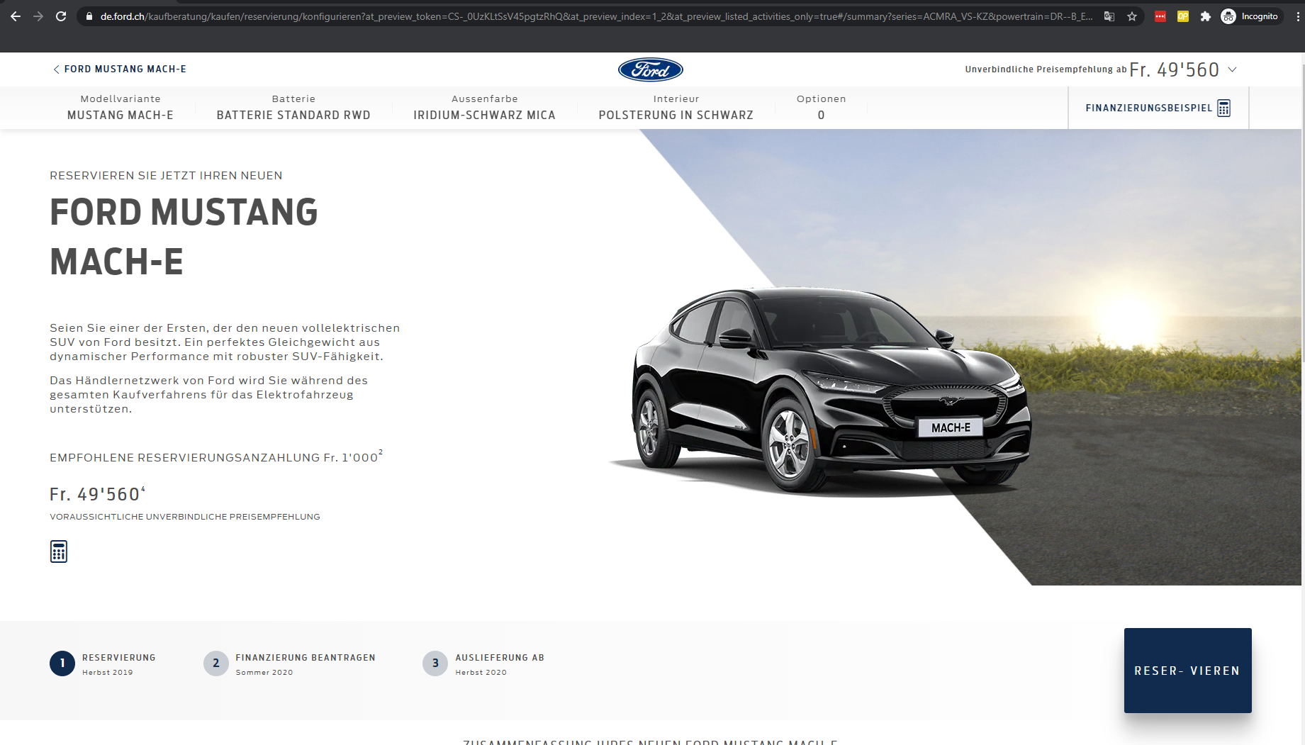

This is a fix for ticket 791 – after the Swiss IT team made changes to the Mach-E BP journey the classes that were used to target elements were changes and this all changes and functionality that were implemented for ticket 791 were undone. I have changed how elements are targeted so that this doesn’t happen in the future. Please check that all changes that were implemented in 791 are back to how they were and everything is working:

Start the Mach-E BP journey. Then on the model, range, colour, interior and extras pages the top right CTA should navigate you to the next step (Excluding range and model) and have a label of the next step.

On desktop the next step buttons should always be above the fold, based on the height of the browser the button will either float to stay in view or return to its original position. When the button is floating due to a lowered height and the user scrolls down, it will float until the Legal Disclaimer heading comes into view, to which it will also return to its original position, scrolling back up to remove the heading from view will have it float again. Nothing happens if the height of the screen is sufficient.

On mobile there are practically no changes, the stickied buttons would be renamed to show the next step instead of just saying pre-order as it does in the control. You’re also able to click the sticked button in order to advance, unless you’re on a screen where a selection is required, in which case it would show an error message.

**Browser:**   
All  
  
**Device:**   
All  
  
**Audience rules:**   
All traffic across all 3x Swiss languages / domains (German, Italian and French)

**QA Links**

**1) Duetsch**

**Control:** <https://www.de.ford.ch/kaufberatung/kaufen/reservierung/konfigurieren?at_preview_token=CS-_0UzKLtSsV45pgtzRhQ&at_preview_index=1_1&at_preview_listed_activities_only=true#>

**Challenger:** <https://www.de.ford.ch/kaufberatung/kaufen/reservierung/konfigurieren?at_preview_token=CS-_0UzKLtSsV45pgtzRhQ&at_preview_index=1_2&at_preview_listed_activities_only=true#>

**2) Francais**

**Control:** <https://www.fr.ford.ch/conseils-d-achat/acheter/reservation/configurez?at_preview_token=k_OpyYm3H-XKCvJLE575og&at_preview_index=1_1&at_preview_listed_activities_only=true#>

**Challenger:** <https://www.fr.ford.ch/conseils-d-achat/acheter/reservation/configurez?at_preview_token=k_OpyYm3H-XKCvJLE575og&at_preview_index=1_2&at_preview_listed_activities_only=true#>

**3) Italiano**

**Control:** <https://www.it.ford.ch/consulenza-agli-acquisti/comprare/prenotazione/configura?at_preview_token=N-dQkBlPfcH4fbif2BDuzA&at_preview_index=1_1&at_preview_listed_activities_only=true#>

**Challenger:** <https://www.it.ford.ch/consulenza-agli-acquisti/comprare/prenotazione/configura?at_preview_token=N-dQkBlPfcH4fbif2BDuzA&at_preview_index=1_2&at_preview_listed_activities_only=true#>